

School of Computing and Mathematics

PRCO303

Final Stage Computing Project

BSc (Hons) Software Engineering

M.T.D Salgado

Smart LMS Mobile App for Primary School Students & Teachers

2021/2022

Contents

1. Introduction 3

2. Purpose 3

3. Background 3

4. Motivation 4

5. Goal 10

6. System Description 10

7. Project methodology 10

8. Learning undertaken and required 11

9. Initial Scope 11

10. Project Plan 11

a. Control Plan 11

11. Tasks undertake & Outcome 12

12. Project Current Implementation 13

a. Interfaces Designs 13

9. Feedback (Supervisor Meetings) 18

13. Schedule 21

14. Initial Risk List 21

15. Initial Quality Plan 22

# Introduction

The smart mobile app is called e-Edu and its clients are primary school students and teachers. The aim is to ensure the safety of students during the covid outbreak period as well as in the post-covid outbreak period that the entire world is facing these days and to enable them to continue their education through modern technology without any hindrance.

I plan to implement a Learning Management System (LMS) to solve certain current issues. Students, Teachers, will be the primary components of this learning management system. These are the most challenging managerial tasks. Which they must do manually at the beginning, mid, and end of each school year.

This Learning Management System (LMS) will make it easy to primary school students and teachers to do their studies and enhance their knowledge using the e-resources in the e-Library.

# Purpose

This report details the processes of the system going to design the smart LMS mobile app for primary schools is called e-Edu. In the Current Situation, students can do their educations and teachers can’t teach their students physically. And students as well as teachers face many difficulties in performing co-curricular activities in the classroom while maintaining social distance. Also, for more than a year, students have not been able to face the exams held at each school term to test their education and their level of knowledge. They lost their lovely school life. Therefore, this smart web version mobile app can be mentioned as a guide for their educational activities.

This system facilitates the successful completion of education not only during the covid outbreak period but also during the post covid outbreak period.

# Background

The government of Sri Lanka has used a variety of control techniques to manage the current coronavirus outbreak in the country, including social distance, quarantine, lockdowns, travel restrictions, and rural isolation. The goal of this study is to use the Internet and modern technologies to effectively address these present issues and develop viable answers. LMS can be take distance education as a solution.

And it is an overhead in the offline system to store teachers, students, parents, and other school staff records on paper. Everything relating to their progress in the system is carefully marked. If I use an online platform for school education, it will be easy for both teachers and students to continue their studies.

This system facilitates the successful completion of education not only during the covid outbreak period but also during the post covid outbreak period.

# Motivation

Following the outbreak of covid-19 in the recent past, the Sri Lankan government imposed a quarantine curfew, shutting down all public and private educational institutions and directing them to do so online. During that time, I came to know that students and teachers had to face many difficulties, especially in the education and teaching activities of the primary grades.

Therefore, I wanted to create an LMS for students and teachers who are doing primary school education and teaching, and for that I collected and analysed the requirements and data required to create an LMS using a google form.

**Smart Learning Management System (LMS) for Primary Schools [e-Edu]**

**Teachers’ Responses**

04. Address (City)

12. Do you feel the need for a Learning Management System (LMS) to carry out learning / teaching activities?

13. What features / functions do you think should be present in the Learning Management System (LMS)?

14. In addition to the features / functions mentioned above, what are the features / functions that you would like to have to facilitate your learning and teaching activities?

* Online Games & Videos
* Online Learning Games
* Tutorial Videos

**Smart Learning Management System (LMS) for Primary Schools [e-Edu]**

**Students’ Responses**

04. Address (City)

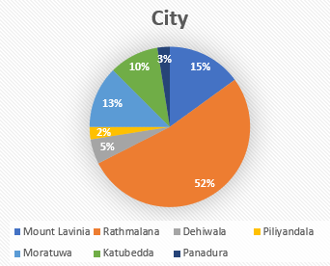

12. Do you feel the need for a Learning Management System (LMS) to carry out learning / teaching activities?

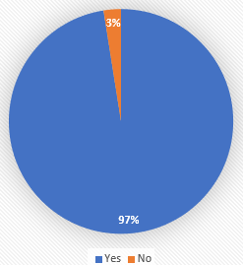

13. What features / functions do you think should be present in the Learning Management System (LMS)?

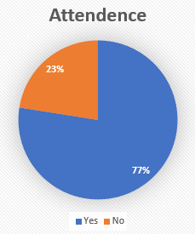

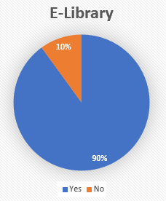

14. In addition to the features / functions mentioned above, what are the features / functions that you would like to have to facilitate your learning and teaching activities?

* Tutorial Videos
* Online learning games

# Goal

The aim is to ensure the safety of students during the covid outbreak period as well as in the post-covid outbreak period that the entire world is facing these days and to enable them to continue their education through modern technology without any hindrance.

# System Description

The first, user should install the application in his/her android device. Because I am developing this application for android devices only. After finishing the installation user can open the application and user must have to signup to application. Then the user has to select whether he / she is a teacher / student. Next users need to select your grade. After user can access their dashboard.

# Project methodology

This LMS will make an incremental approach. This approach will target and focus on,

**I. E-Learning**

Students and teachers can learn and teach through mobile Application.

**II. Internal Communications**

Between admin, students, and teachers – through Mobile Application.

**III. Interoperability with students’ and teachers’ applications**

Between admin, Staff member and teachers – through Mobile Applications.

My development approach of this project will be undergoing with Prototype Methodology. This management method will help me to finish project within deadlines, respectively. Technologies that I plan to use are WordPress, Java and Xml. Visual studio Code, Sketchware are used as IDEs for development. This project will contain different types of apps for different types of tasks for users, such as admin and Users (students & teachers).

# Learning undertaken and required

* Learned Java programming language
* Learned Wordpress technology
* Learned Firebase
* Learned how to work Sketchware mobile app

# Initial Scope

**Scope (01): - Login**

According to the user type provide a login module with a different privileges and functionalities. provide login into the system securely by validating username and password. Also, user can be log out from the system.

**Scope (02): - Registration**

When joining the system, get details from the online register form and the system will record user details as necessary.

**Scope (03): - Dashboard**

Dashboard is the main thing for user. Username will display on top of the page. There are two themes used for the dashboard for students and teachers. The dashboard interface includes many features such as My subjects, My timetable, Announcement, Exams & Results and Library.

**Scope (04): - Announcements & Notice**

This section allows teachers for give some important messages to students or their parents.

**Scope (05): - Exams & Results**

Exams & results section only for teacher for conduct term test via online. After give marks and student can get their marks.

**Scope (06): - Library**

This sectionforboth of students and teachers. They can refer e-books for improve their knowledge.

# Project Plan

## Control Plan

I’ll be using Protype Methodology as a project planning technique.

* Reports highlighting weakly at the end of stages.
* Review meetings with supervisor until the end of project.
* Risk Management
* Communication Plan
* Quality Plan
* Exception Reports

# Tasks undertake & Outcome

|  |  |  |  |
| --- | --- | --- | --- |
| Task ID | Tasks | Outcomes | Status |
| 01 | Investigation & Requirements | Analize the gathering data of user requirements and challengers faced by students & teachers.  Evaluation of technologies for development. | Done |
| 02 | High-Level Design | Design and implement scabble database with appropriate requirements. | ToDo |
| 03 | Increment I (Website) | Creating Learning Management System (LMS) web application. | 50% Done |
| 04 | Increment II (Mobile App) | Creating user mobile application. | ToDo |
| 05 | Increment III (Mobile App) | Creating admin mobile application. | ToDo |

# Project Current Implementation

## Interfaces Designs

This is current progress of my project.

Home Page

Login Page

When user click on login tab he or she can see like these interfaces.

If you are new user, you have to signup first. If isn’t you can login.

e-Library Page

Pre-School Page

# Feedback (Supervisor Meetings)

The support received from the supervisor is very helpful in order to perform background research on various techniques and also for the implementation. Regular meetings with the supervisor were happened and the guidance received from the supervisor meetings lead this project to this much distance.

**9.1 Supervisor Meeting - 01**

**Final Year Project – Supervisory meeting minutes**

Meeting No: 01

Date : 9th November,2021

Project Title : Smart LMS Mobile app for School Students

Name of the Student : M.T.D Salgado

Students ID : 10707355

Name of the Supervisor : Mr. Mohamed Shafraz

**Items discussed:**

* Project topic (project idea).
* Problem statement.
* About the technologies intended to be used for the project.
* Project Initiation Document (PID).

**Items to be completed before the next supervisory meeting:**

* Change Project topic name.
* Complete Project Initiation Document & submit it before deadlines.

……………………….

…………………………………..

Supervisor (Signature & Date)

**9.2 Supervisor Meeting – 02**

**Final Year Project – Supervisory meeting minutes**

Meeting No: 02

Date : 24th November,2021

Project Title : Smart LMS Mobile app for School Students

Name of the Student : M.T.D Salgado

Students ID : 10707355

Name of the Supervisor : Ms. Chalani Oruthotaarachchi

**Items discussed:**

* Project topic (project idea).
* Problem statement.
* About the functionalities that will be used for the project.

**Items to be completed before the next supervisory meeting:**

* Design a questionnaire and collect data from students and teachers about the functions they need for LMS & Analyze the collected data.
* Research existing systems for schools LMS.

……………………….

…………………………………

Supervisor (Signature & Date)

# Schedule

# Initial Risk List

# Initial Quality Plan

